Website Operation Guide

- Register - How to register?
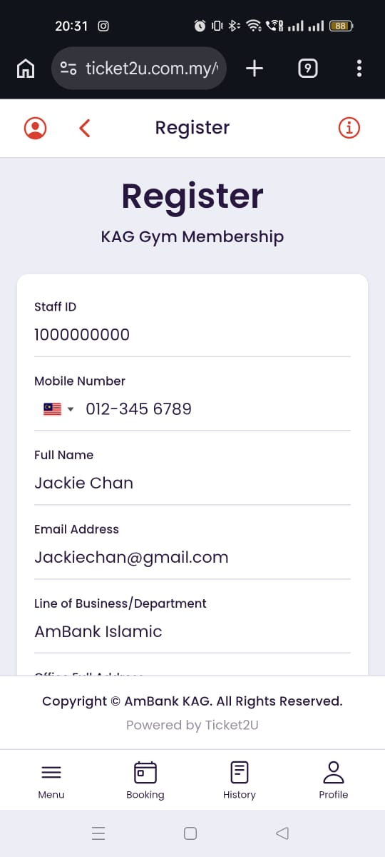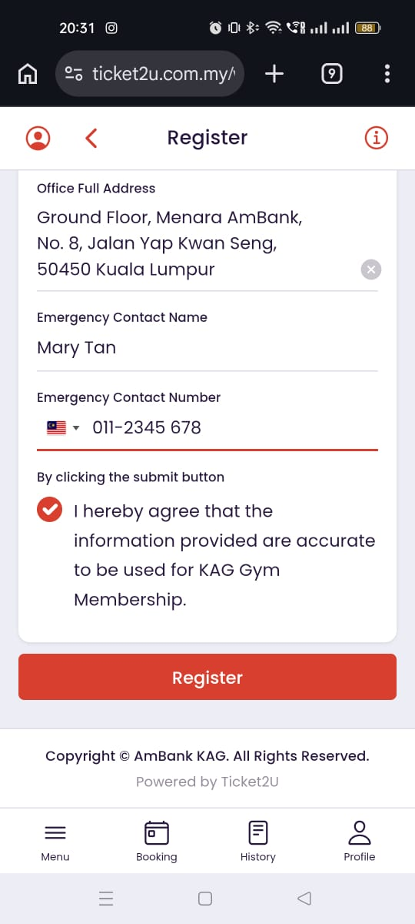

Follow the steps below to register a new account:
Fill in your personal details:
- Staff ID: Enter your company staff ID.
- Mobile Number: Enter your active mobile phone number (used to receive OTP verification).
- Email Address: Enter your active email address.
- Line of Business/Department: Enter your department or business unit (e.g., IT, Finance, Operations).
- Office Full Addrress: Enter your office's full address.
- Emergency Contact Name: Enter the full name of your emergency contact person.
- Emergency Contact Number: Enter the active phone number of your emergency contact person.
- Declaration / Agreement: Tick the checkbox to confirm and agree that the information provided is accurate.
If your already register Please move to the Login page: https://www.ticket2u.com.my/v3/kag/login

- Login - How to login?
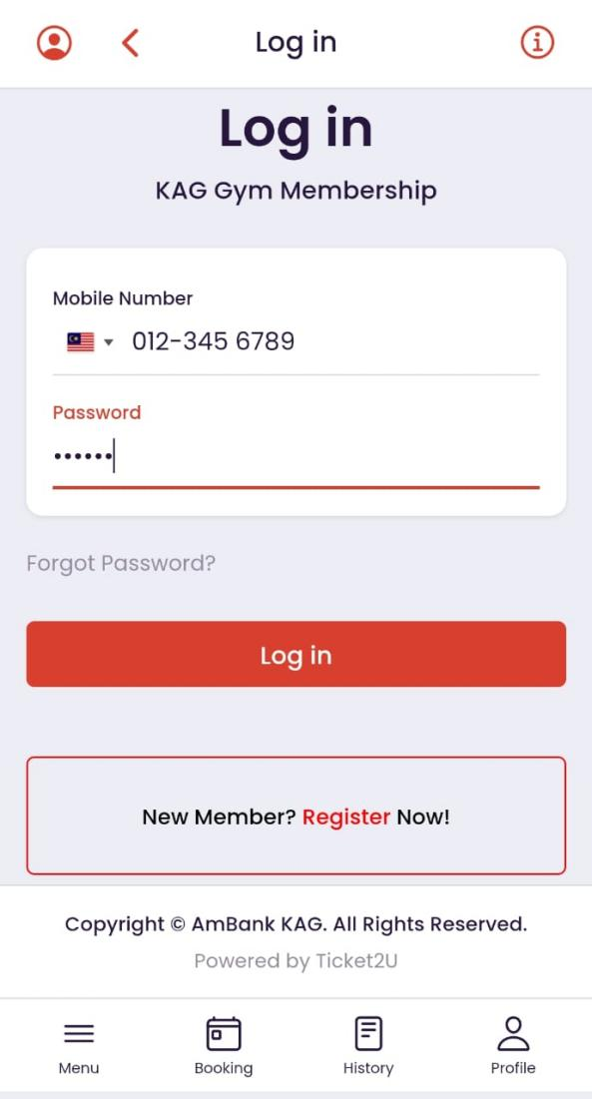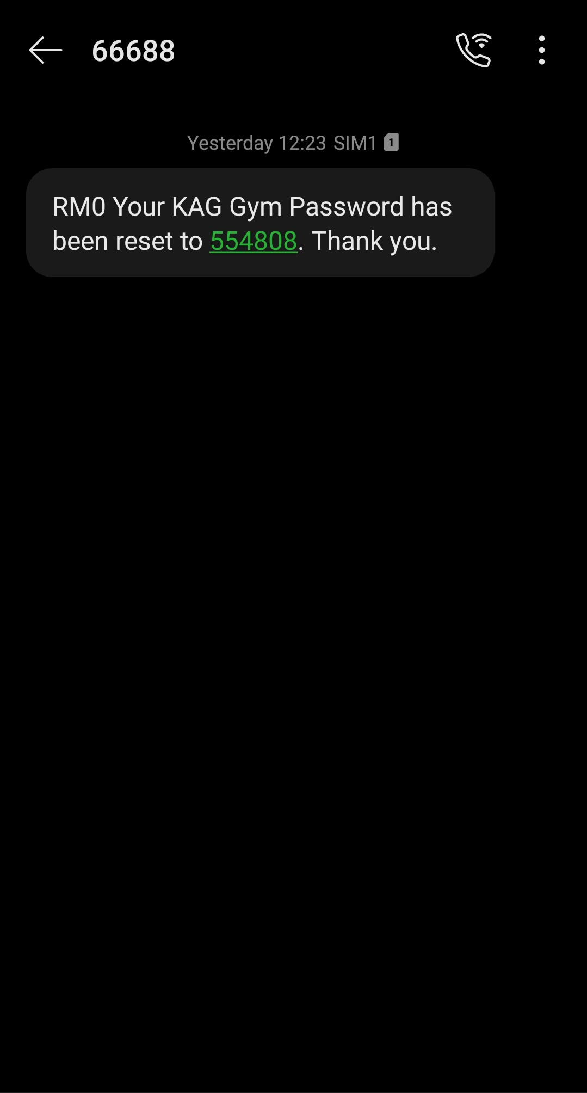

Follow the steps below to register a new account:
Fill in your personal details:
- Mobile Number: Enter your mobile phone number when you register.
- Password: you will receive OTP code after register and the otp is your password please save propoly
If your haven’t register Please move to the Register page: https://www.ticket2u.com.my/v3/kag/register
- Facial ID = How to make Facial ID
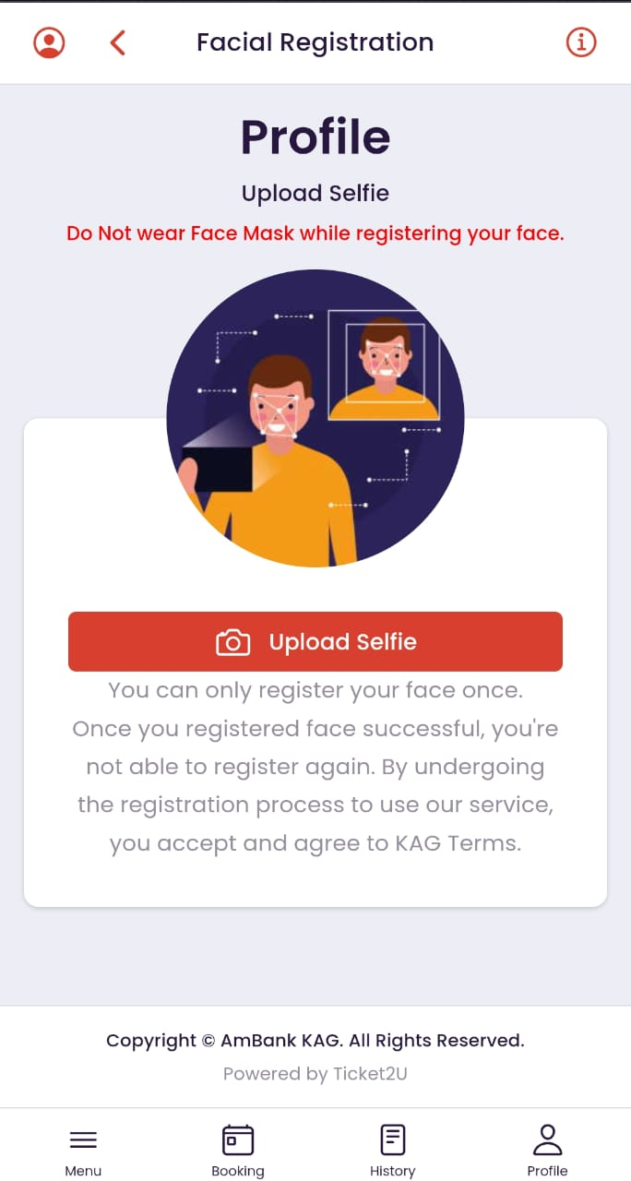

Follow the steps below to register Facial ID:
- Press Uoload selfie and please select camera no video
- Please confirn your evinoment is bright, and cloed your camera
- Please use your personal face because this face will become your chack in face.
- Purchase/Renew Membership - How to make payment
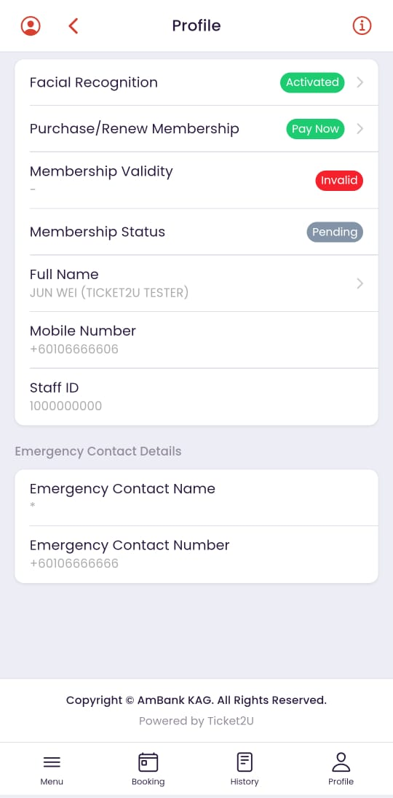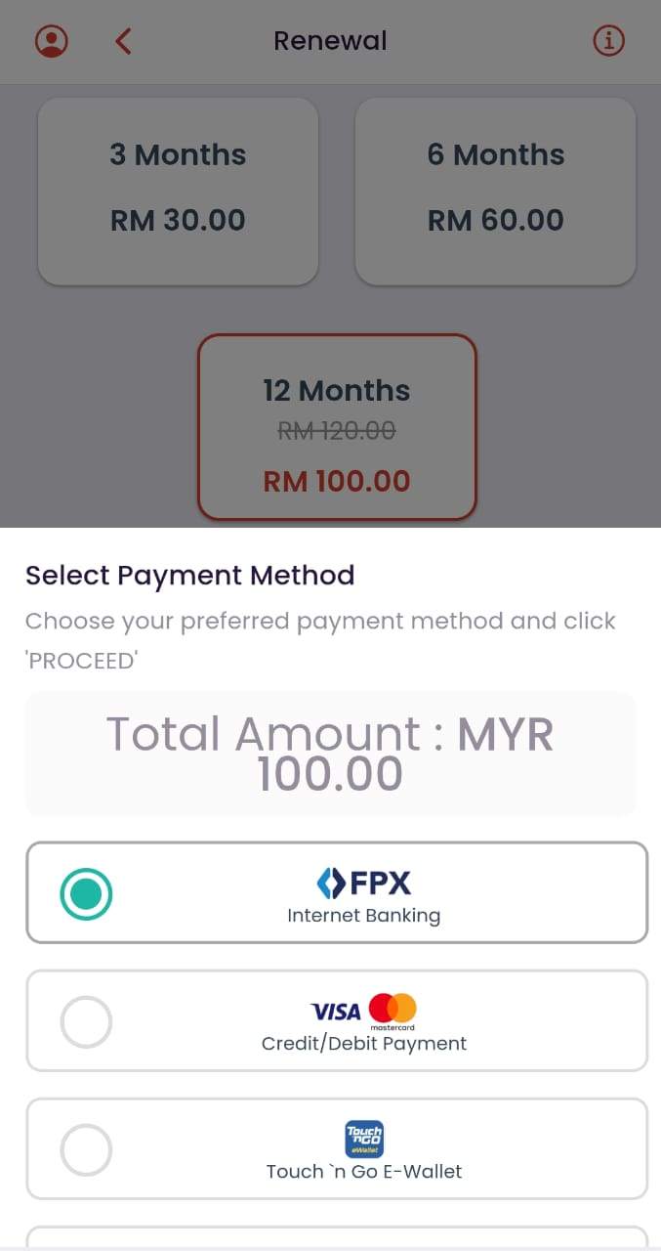

Follow the steps below to Purchase&Renew Membership:
- Before your Purchase&Renew Membership, please make sure your are already activated facial recognition.
- After your press Purchase&Renew Membership button your can see a few choice can choose.
- Select your own plan and press make payment button.
- Selection your payment method
- After payment please wait for the messenger
- After your get the messenger gong xi your and you can start booking now.
- Manu - How to make a booking
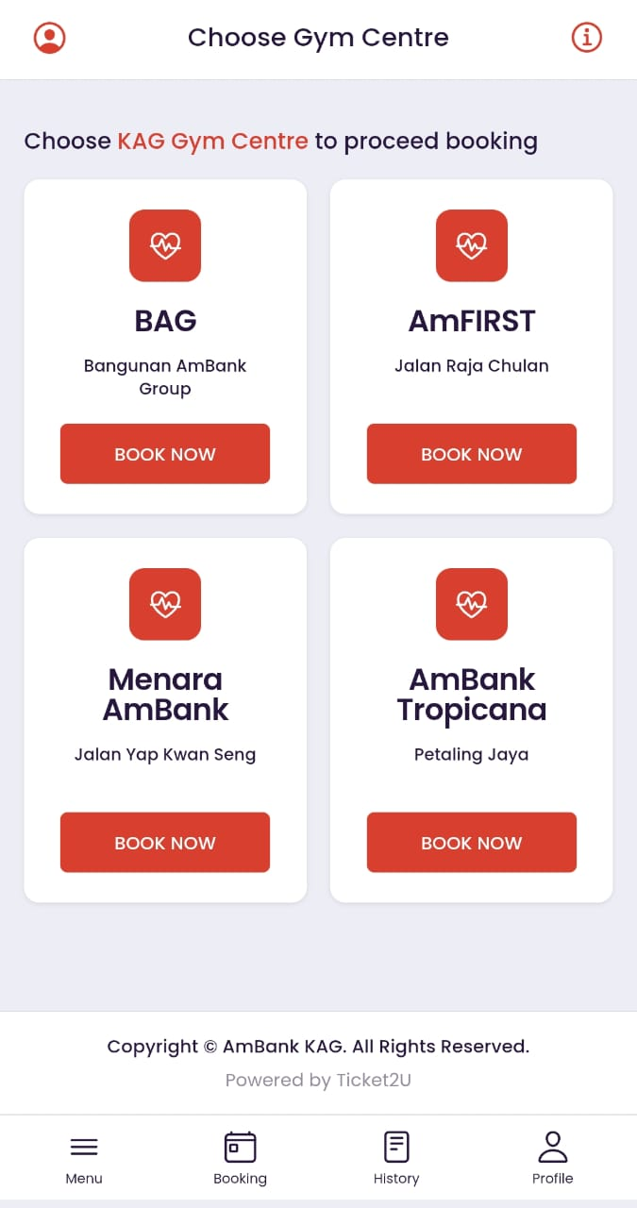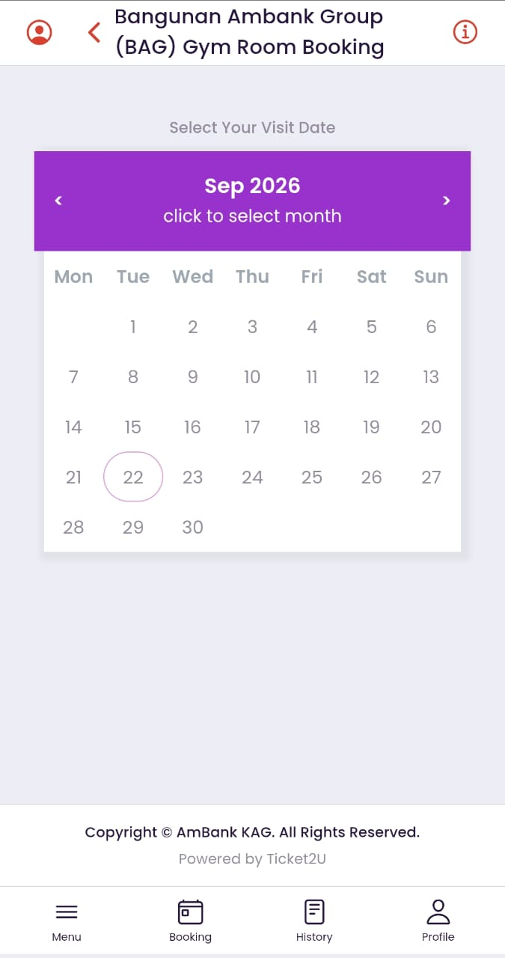

Follow the steps below to booking:

- Press the Booking button to enter this page
- Select your place to make a booking
- Select your prefect day
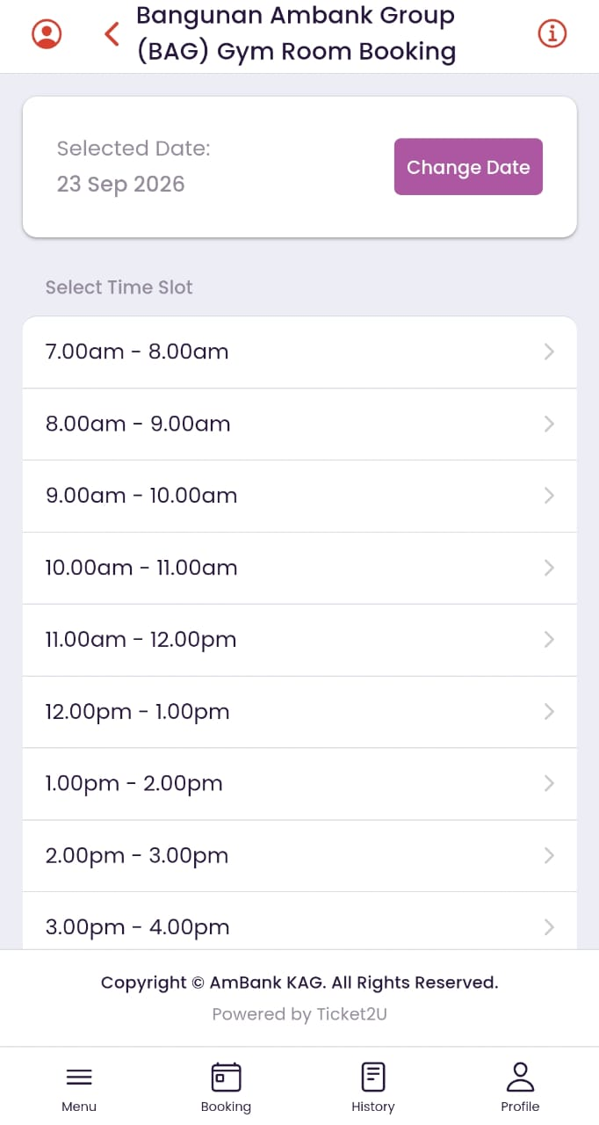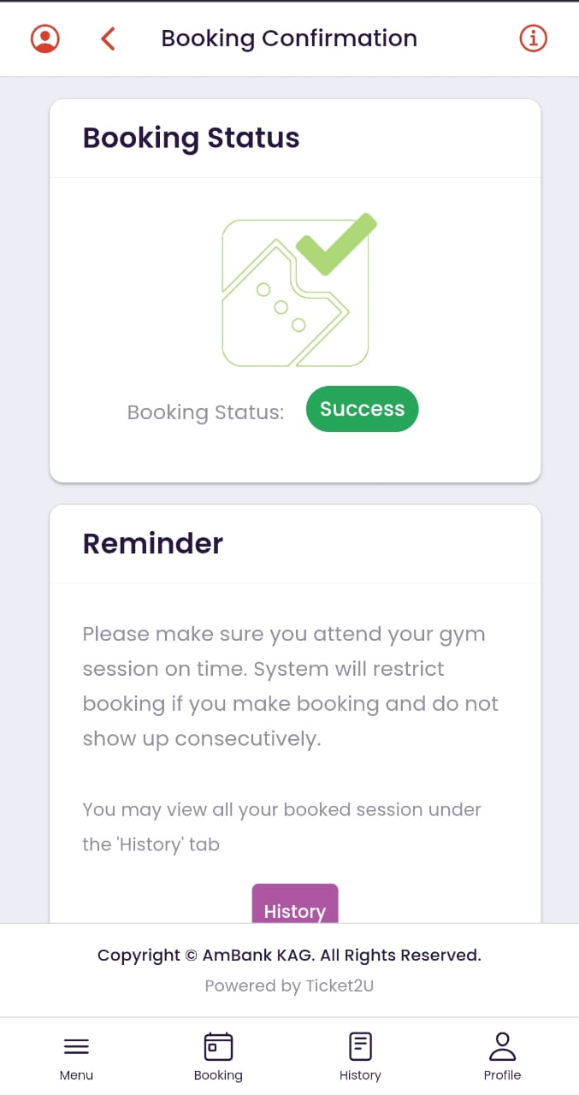
- After you select please select your time
- And press book button to continue
- After that your will see the new page is say booking status success
- To make sure you booking your can press the button to go to history

- History - How to check your history booking
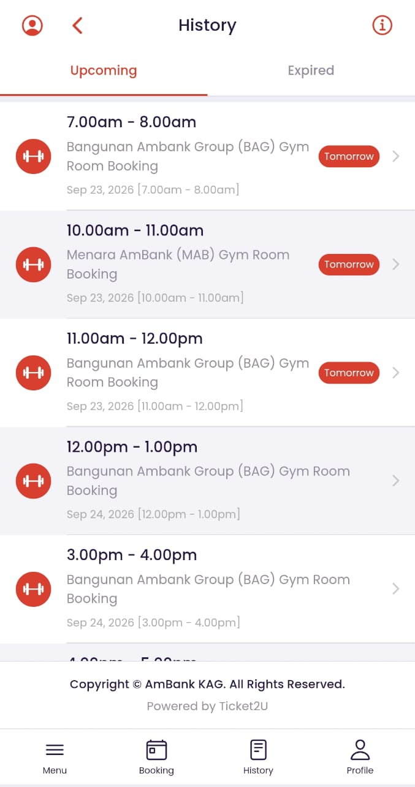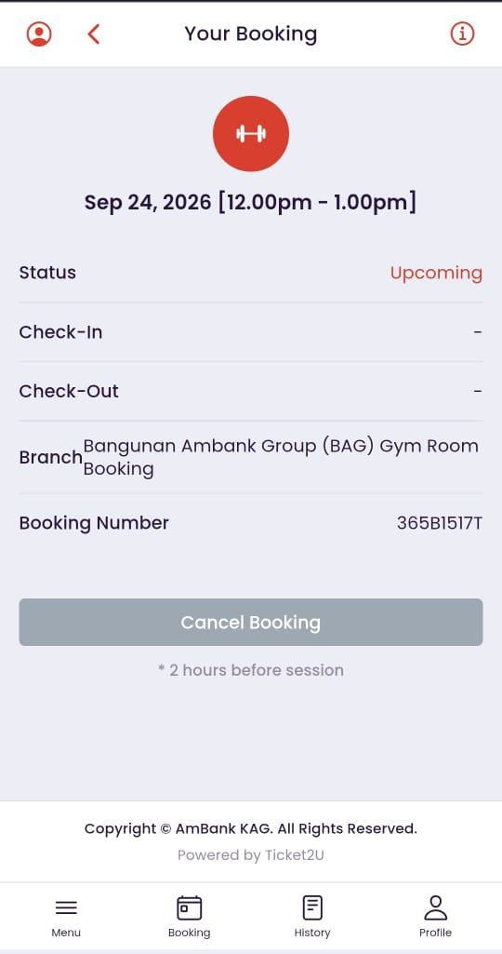

Follow the steps below to check your booking:
- After you booking your can press the button history below to check your booking history
- Select the day your want to see the detail
- You can cancel booking for your are no free
- After cancel your are not allow to check in
- You can booking back the same day.

- Feelback - How to make a feedback
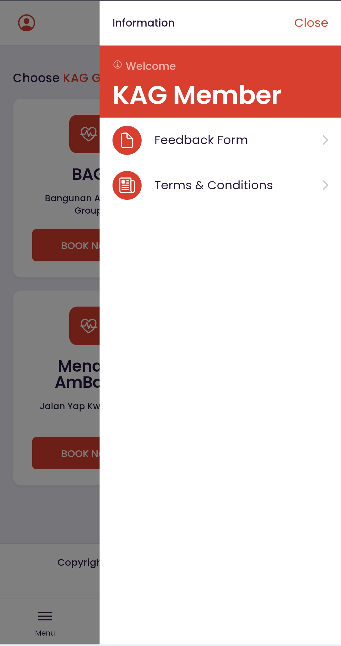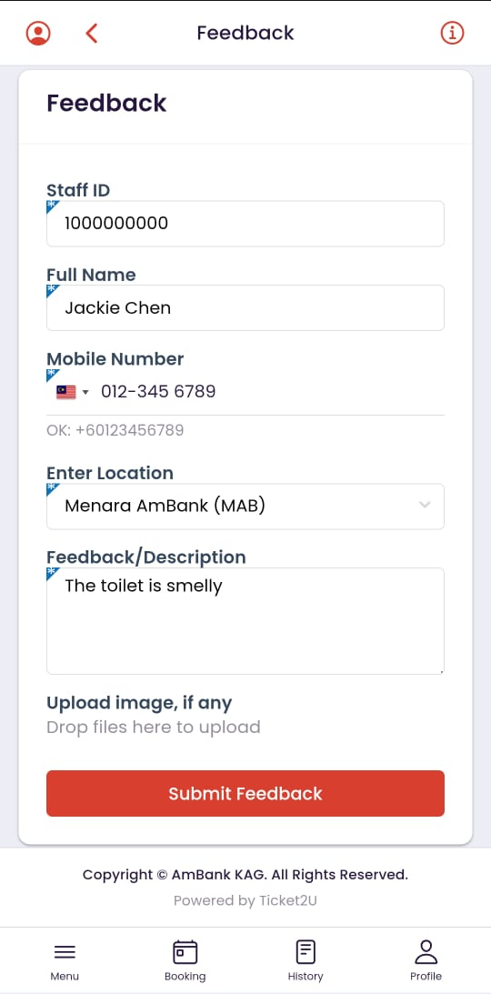

Follow the steps below to check your booking:

- Press the feedback form button.
- Confirm your information and your contect number is working
- Make sure your number is working eazy we follow back.
- Select your specific Location
- And say what is your problem here
- Your can upload image if any
- After submit feedback your will see the picture 2 will say thank you

- Terms & Conditions
Follow the steps below to see our terms & conditions:

- Tap the Menu icon on the bottom navigation bar.

